Code #BU21
Bulletin Change Transmittal Form
Undergraduate Curriculum Council - Print 1 copy for signatures and save 1 electronic copy.
Graduate Council - Print 1 copy for signatures and send 1 electronic copy to mmcginnis@astate.edu

Bulletin Change
Please attach a copy of all catalogue pages requiring editorial changes.
J.K. Sinclaire March 24, 2014  Department Curriculum Committee Chair Date | COPE Chair (if applicable) Date
Department Chair Date | General Education Committee Chair (if applicable) Date
College Curriculum Committee Chair Date | Undergraduate Curriculum Council Chair Date
College Dean Date | Graduate Curriculum Committee Chair Date
 | Vice Chancellor for Academic Affairs Date
1. Contact Person (Name, Name of Institution, Address, Email Address, Phone Number)
Jollean Sinclaire, ASU / CIT Department, Box 130, State University, jsinclaire@astate.edu, (870) 972-3416
2. Proposed Change
Revise CIT 1503 requirement for AS Degree in Computer & Information Technology: Delete specification that states CIT 1503 Microcomputer Applications requirement may be satisfied by passing the College of Business hands-on computer proficiency exam.
3. Effective Date
May 15, 2014
4. Justification
The College of Business hands-on computer proficiency exam has been retired because the technology used to deliver it has become obsolete. The test is no longer available.

From the most current electronic version of the bulletin, copy all bulletin pages that this proposal affects and paste it to the end of this proposal.

To copy from the bulletin:
- Minimize this form.
- Go to http://registrar.astate.edu/bulletin.htm and choose either undergraduate or graduate.
- This will take you to a list of the bulletins by year, please open the most current bulletin.
- Find the page(s) you wish to copy, click on the “select” button and highlight the pages you want to copy.
- Right-click on the highlighted area.
- Click on “copy”.
- Minimize the bulletin and maximize this page.
- Right-click immediately below this area and choose “paste”.
- For additions to the bulletin, please change font color and make the font size larger than the surrounding text. Make it noticeable.
- For deletions, strike through the text, change the font color, and enlarge the font size. Make it noticeable.

Current Page 139
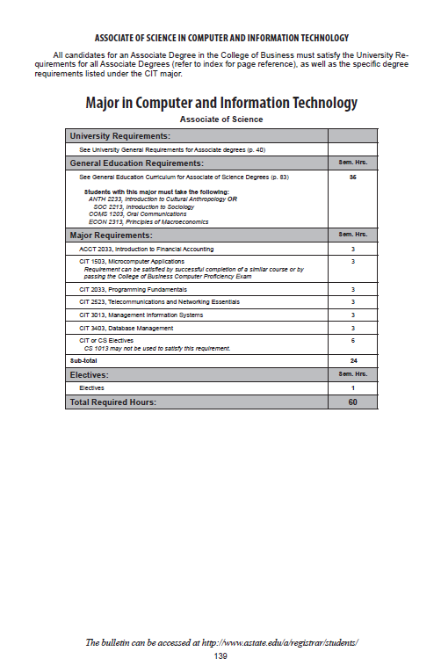

Current Page:
CIT 1503, Microcomputer Applications
Requirement can be satisfied by successful completion of a similar course or by passing the College of Business Computer Proficiency Exam

Change highlighted section to:
CIT 1503, Microcomputer Applications or CS 1013, Introduction to Computers

